**PsyBSc 11: Emotion 2 (Vorlesung 2)**

**Topic: Theories and classic controversies in emotion psychology**

Inhalt

1. Specificity problem 2

1.1 Definition 2

1.2 Arguments in favor of specificity 2

1.2.1 Physiological profile of arousal 2

1.2.2 Study by Ekman et al. (1983) 2

1.2.3 Body temperatures and emotional experience 3

1.2 Arguments against specificity 3

1.3.1 Imaging studies 3

Summary 4

2. Sequence problem I 4

2.1 Components of emotion 4

2.2 Question 4

2.3 James-Lange-Theory 5

2.4 Arguments of Cannon & Bard 5

2.4.1 Experimental activation of emotion centres 6

2.4.2 Valins effect (heartbeat feedback) 6

2.4.3 Somatic Marker Theory (Damasio, 1996) 7

3. Sequence problem no. 2 11

3.1 Definition 11

3.2 Two positions 11

3.2.1 Study in favor of Lazarus 12

3.2.2 Transactional stress model (Lazarus, 1966) 12

3.2.3 Study in favor of Lazarus 13

3.3 Neuroscience data on the controversy over primacy 13

3.4 Conclusion 15

4. Applications 16

4.1 Polygraph: Lie Detection 16

4.2 Cognitive model of panic (Clark, 1988) 16

4.3 Psychophysiological model of panic attacks (Ehlers et al., 1989) 17

# 1. Specificity problem

## 1.1 Definition

Are basic emotions associated with a specific physiological profile?

Can you infer from the physiological component which experience is currently being experienced?

## 1.2 Arguments in favor of specificity

### 1.2.1 Physiological profile of arousal

Ein Bild, das Tisch enthält.

### 1.2.2 Study by Ekman et al. (1983)

From Schneider, 1992, S.417

You see differences in heart rate and temperature change, (but they are not enough to distinguish the emotions by themselves)

### 1.2.3 Body temperatures and emotional experience

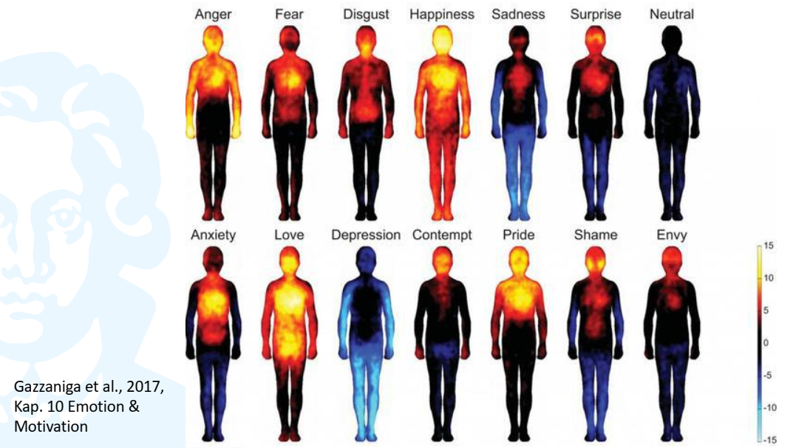

**Findings from a study by Nummenmaa et al., 2014**

* Body temperature as associated with emotions
* You can see how the emotions relate to adaptive functions they are subserving

(e.g., when you’re angry 🡪 fists; love = like happiness + genitals; disgust 🡪 bowel area)

## Arguments against specificity

### 1.3.1 Imaging studies

**Phan et al. 2002 (meta-analyses of 55 PET and fMRI studies)**

Ein Bild, das verschieden, mehrere enthält.
Are there specific activation patterns for certain emotions?

* No specific activation patterns for certain emotions
* Clustered activations for fear in amygdala; disgust in insula; sadness in subcallosal cingulate
* Activation pattern depends on induction method
* Medial prefrontal cortex (mPFC) was commonly activated in emotional experiences

## Summary

* Specificity problem cannot be clearly answered
* Different emotions are often associated with different peripheral physiological profiles, but not very reliably.
* The valence dimension is difficult to differentiate via peripheral measures.
* Imaging techniques reveal: some brain regions seem quite specific, but what is being computed remains unclear (e.g., amygdala = also boosts learning and perception). Other regions seem even more unspecific, esp. in regard to valence
* No researcher can read off the emotion from a profile of physiological reactions without a doubt

# 2. Sequence problem I

## Components of emotion

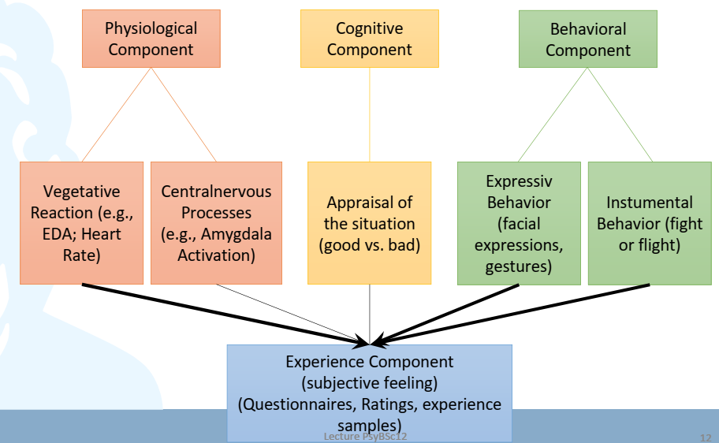

## 2.2 Question

Does affective experience precede physiological reactions or vice versa?

## 2.3 James-Lange-Theory

* James (1884) and Lange (1885) came up with this idea at around the same time
* We experience certain patterns of physiological reactions, this causes the experience of emotions: “We tremble not because we are scared, but we are scared because we tremble”

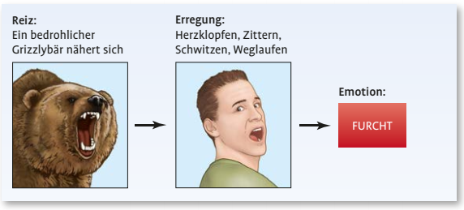

## 2.4 Arguments of Cannon & Bard

Cannon (1927) und Bard (1934) criticize the theory that was postulated by James & Lange.

Arguments:

|  |  |
| --- | --- |
| **Against Lange** | **For Lange** |
| The same visceral changes occur in very different emotional and non-emotional states; you would need distinct physiological patterns to derive certain emotions from them. | This argument is partially backed by empirical evidence. Some emotions can be distinguished by physiological changes (e.g., Ekman) |
| Humans are not sensitive towards visceral changes | There is introspection: individuals with high intereoceptive abilities show higher emotional sensitivity (Schandry lab) |
| Visceral changes are slow and take a long time to reach the CNS, while emotional experience can happen quickly | Efference copy: When your brain puts out a signal to your body to increase arousal, it will send a copy of that demand to other parts of the brain. Other parts of your brain may know of the command to increase activity before it arrives in the body. |
| The complete deafferentiation of the internal organs (viscera) does not lead to any qualitative change in the emotional experience, e.g. in paraplegics | Hohmann (1966) reports that patients with visceral deafferentation report reduced emotional sensitivity |
| Artificial induction of the visceral changes typical for strong emotions does not lead to the occure of these emotions | Adrenaline only makes you feel “as if” you were excited/happy |
| **Experimental stimulation of certain centres in the brain leads to emotional expression behavior** |  |
|  | **Feeding back arousal leads to altered affective evaluations (experiments by Valins)** |
|  | **Somatic Marker Theory (Damasio, 1996)** |
|  |  |

**Their proposal**

* Information concerning emotional stimuli are sent at the same time and separately both to the cortex and the body
* Emotional stimulus 🡪 thalamus (limbic system) 🡪 cortex / body
* Humans experience two things at the same time: emotion that was produced in the cortex and a physical reaction that was produced outside of the cortex

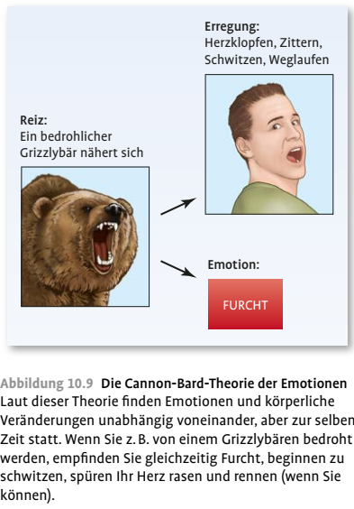

### 2.4.1 Experimental activation of emotion centres

Figure shows aggressive behaviour during stimulation of medial parts of the hypothalamus.

Ein Bild, das Text, Katze, schwarz, weiß enthält.
See also:

* Electrical brain stimulation by Penfield in humans reliably induced feeling states in patients with epilepsy
* Drugs that activate dopamine pathways induce liking and wanting states and thereby addiction

### 2.4.2 Valins effect (heartbeat feedback)

Most people are insensitive to their heart beat.

* **Two conditions:**

1. False Feedback of Heartbeat, “this is your heartbeat” (experimental)
2. External sound, “this is just noise” (control)

* **Dependent variable**: attractiveness rating of pictures
* **On some pictures (naked women), they made the rhythms of the heartbeat faster**
* **Ein Bild, das Text enthält.

  Automatisch generierte BeschreibungResult**: Correlation between perceived change of heart rate and evaluation of attractiveness

### 2.4.3 Somatic Marker Theory (Damasio, 1996)

This theory can be seen as a modern variant of the James-Lange Theory. Damasio’s theory was inspired by a patient with vmPFC lesion

**Patients with vmPFC lesions (like Phineas Gage)**

* Intact intellectual and memory functions
* Difficulties with affect inhibition
* Limited social competence (impulsive, unreliable)
* Difficulties with goal-maintenance and goal-shifting as in reversal-learning
* Difficulties with risk anticipation and decision making

Damasio wanted to perform a task that quantifies this deficit that primarily affects emotional and social life:

**Iowa Gambling Task (Bechara et al., 1994)**

Ein Bild, das Text, verschieden, mehrere, Gewebe enthält.

* You get 4 decks of cards
* You draw a card to increase points
* Cards A and B 🡪 100 points; Cards C and D 🡪 50 points
* But: on the backside there are losses
* Erwartungswert bei A&B = -25 und bei C&D = 25
* Thus, you have to learn that C & D is better than A & B

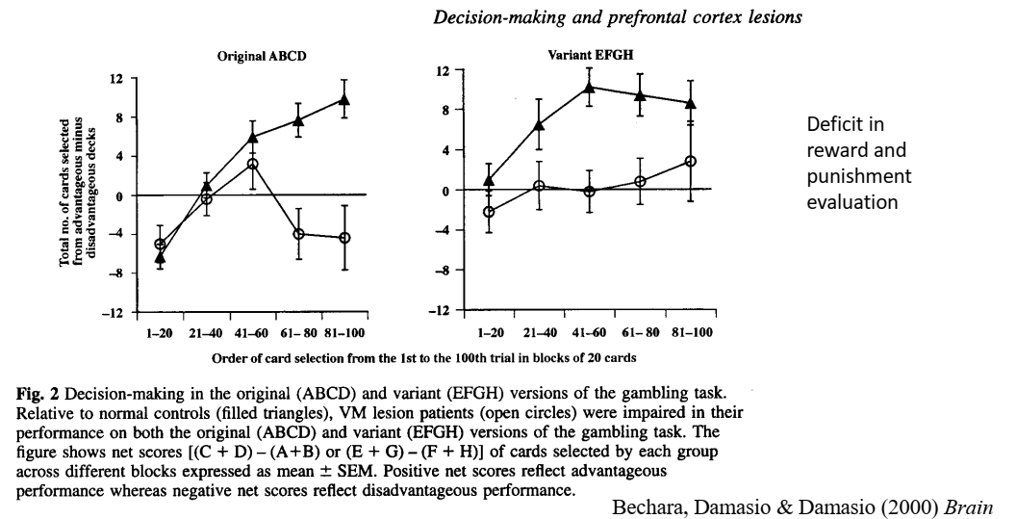

**Patients (with clear circles) don’t show a learning curve towards decks C & D unlike control group**

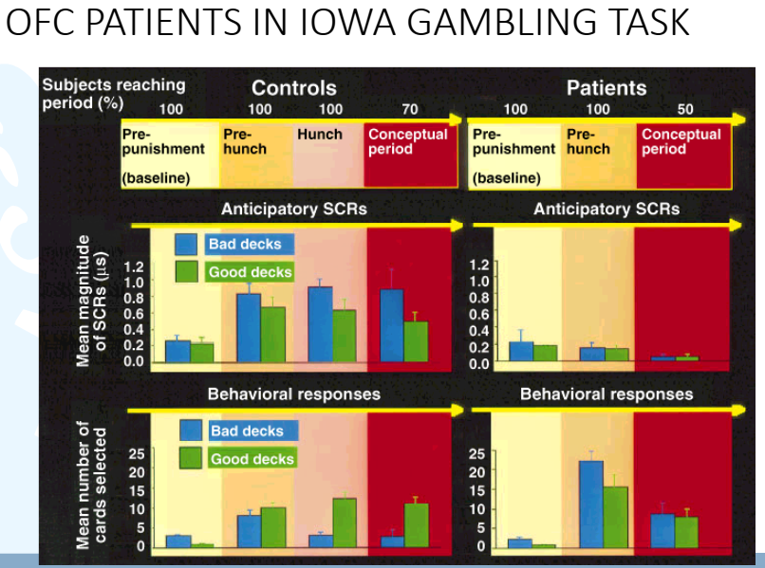

On the left: 4 phases because at first, they have no clue what’s going on (Pre-punishment / baseline), then pre-hunch (they still don’t know, but subconsciously feel something’s off), then hunch, then they understand the concept (70%)  
SCR = skin conductance ratings (measurement of excitement); crucial is pre-hunch condition where SCR is higher for bad decks in controls which leads to hunch and changed behavior in phase 3

Patients lack physiological signal that informs them about threat in the environment; even if they have conceptual knowledge, they’d rather go with their intuition that is uninformed

**Interpretation of patient behavior in Iowa Gambling Task**

* Initially, peripheral emotional reactions are of essential importance in the evaluation of choice options
* Why does the brain need this long route to inform itself about the right route?
* Later: probably also an inner cerebral copy of the physiological efference is sufficient 🡪 “short route via efference copy”
* Two paths by the brain: physiological reaction + cognitive evaluation

**2.5 Two factory theory of emotions**

**Hypothesis**: a physiological arousal is cognitively attributed towards an object/situation in the environment; this leads to the experience of an emotion.

* when arousal cannot be explained, the cognitive evaluation of the context determines the emotion experienced
* They agree with Lange: experience of a physiological reaction leads to emotional experience
* They also agree with Cannon and Bard: too many emotions, that don’t have unique activation pattern

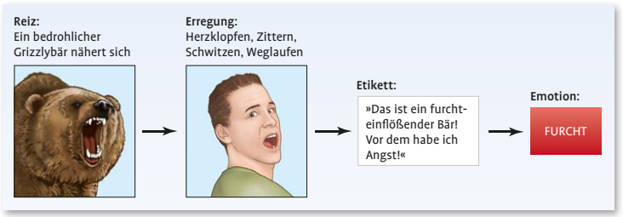

**Experiment by Schachter and Singer**

Hypothesis

Cognitive attribution of a physiological change determines experience and labelling of emotion. If you don’t know why your physiologically aroused, you will be more joyous or more angry because of the environment. If you know that your physiologically aroused due to the injection, you will not experience an emotion and label the physiological experience as an effect of the injection.

Conditions

• UV 1: Injection of adrenaline or saline solution  
• UV 2: Explanation offered: a) correct (arousal), b) false (headache) or c) no information. Placebo group was not informed about effects.  
• UV 3: Cognitive evaluation (context): During a 20 minute waiting period an ally mimed anger or joy

Dependent variable

* Emotional state

Unclear findings

• placebo behaved like uninformed adrenaline group, as if physiological excitation made no difference  
• mood values are quantitatively little changed, only partially significant  
• Some cells are missing from the investigation plan.  
• Follow-up studies (e.g. Marshall and Zimbardo, 1979) confirm this: Artificial Arousal is not decisive and anyway rather aversive, also in the condition of euphoria.  
• Result not replicated  
◊ another „proof of concept“ study

**We have to know the set-up, not necessarily the findings!**

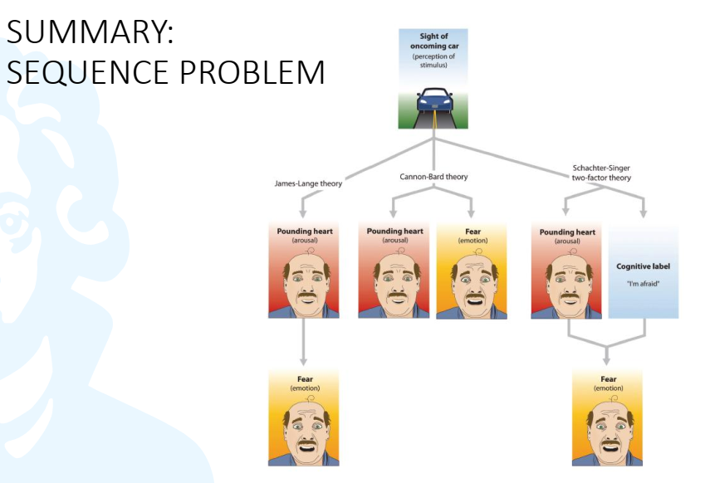

# 3. Sequence problem no. 2

## 3.1 Definition

Do we need cognitive evaluation to trigger emotions?

## 3.2 Two positions

1. Richard Lazarus (stress researcher): Yes

* Primary appraisal: positive or negative?
* Secondary appraisal: available resources? How can I cope?
* Re-appraisal

1. Zajonc: No “preferences need no infereces”

### 3.2.1 Study in favor of Lazarus

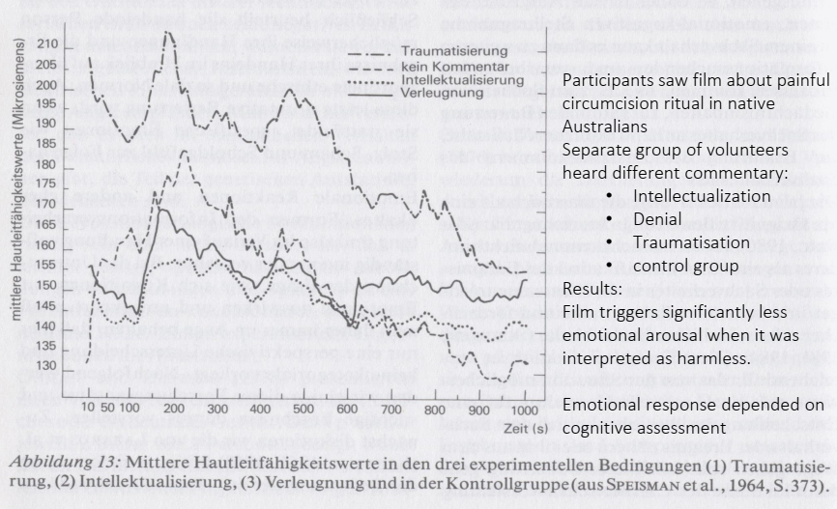

**Study suggests that intensity of emotional response is modulated by cognitive assessment**

### 3.2.2 Transactional stress model (Lazarus, 1966)

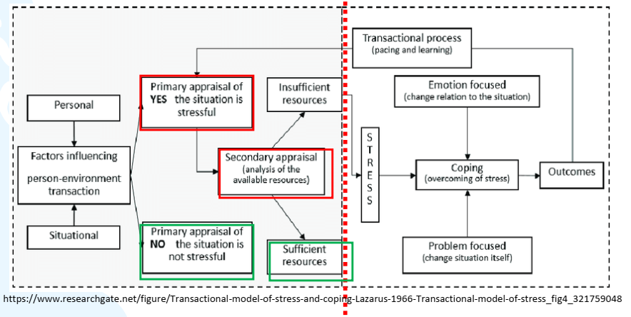

Green = no stress 🡪 no emotional response

Emotion is present from the red line on

Zajonc (1980) preferences need no inference

### 3.2.3 Study in favor of Lazarus

* If you have been shown one of those images briefly beforehand, you will select that shape more often than the other one that is unfamiliar
* Even if you are entirely unaware that you have seen it, you will prefer it
* You have emotional response and cognitive evaluation, even though this decision comes from a subconscious emotional evaluation

Ein Bild, das Kleiderbügel, Unterwäsche enthält.

## 

## Neuroscience data on the controversy over primacy

### 3.3.1 Anxiety conditioning without neocortical processing

* Learning to predict danger
* CS tone, UCS shock
* CR: increase in blood pressure, solidification, stress hormones, etc.
* LaDoux ablated the auditory neocortex
* But you can show fear conditioning behavior even if the stimulus is not processed in the neocortex

### 3.3.2 Two routes of emotional processing

**Two routes:**

1. Quick and dirty processing

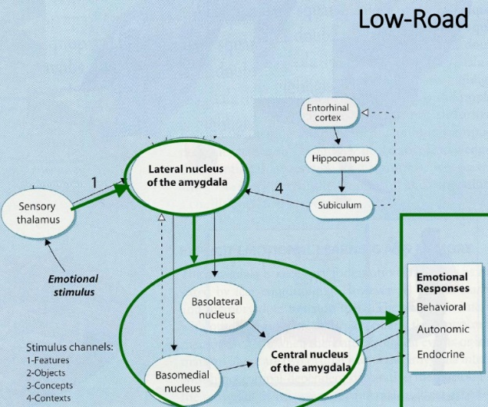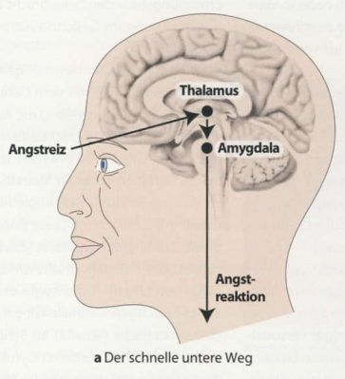Emotional stimulus 🡪 sensory thalamus 🡪 lateral nucleus of amygdala 🡪 central nucleus of the amygdala 🡪 emotional response

1. Elaborate processing with cognition

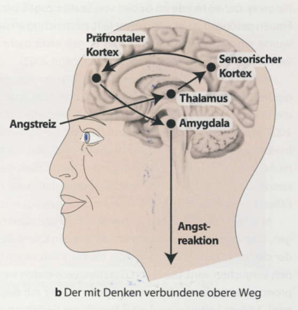Emotional stimulus 🡪 Sensory thalamus 🡪 neocortex 🡪 lateral nucleus of the amygdala 🡪 central nucleus of the amygdala 🡪 emotional responses

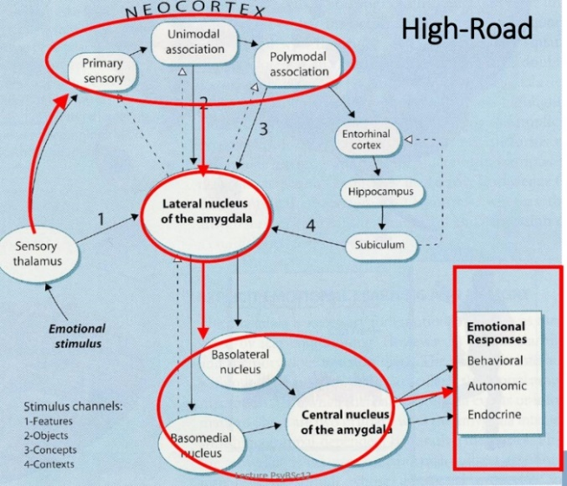

**You need neocortical and hippocampal involvement to modify/evaluate rudimentary emotional experiences**

## 3.4 Conclusion

• Rudimentary emotional reactions can be triggered entirely without prior cognitive evaluation (e.g., sympathy, phobias, antipathy) 🡪 hard to modulate with cognition (Zajonc, LeDoux)

* More complex emotions like depression, hate, love can be influenced by our interpretations, memories and expectations (Lazarus, Schachter-Singer)  
  • The central subcortical trigger station for anxiety emotion is the amygdala.  
  • However, cognition has a modulating effect on emotional reactions (and on amygdala activity).  
  ◊ Emotions can arise without cognition, but the two are interwoven

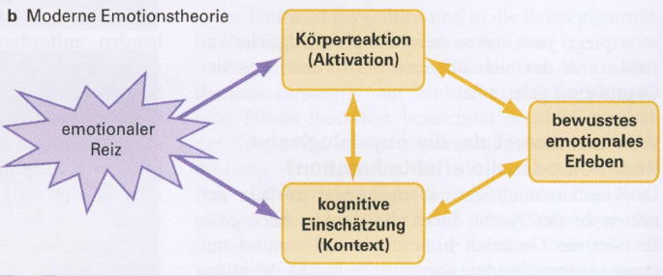

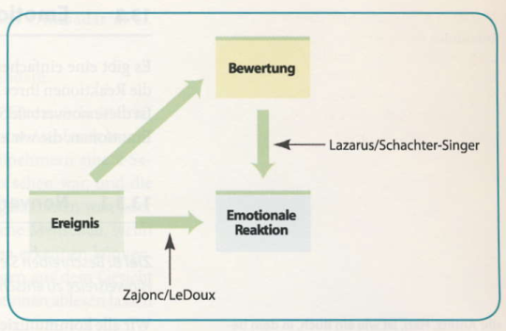

Zajonc & LeDoux emphasize that an emotional reaction can occur without previous cognition. Lazarus & Schachter-Singer emphasize that the appraisal and interpretation of events can influence our emotional experience.

# 4. Applications

## 4.1 Polygraph: Lie Detection

Application of the specificity problem

Idea: from your peripheral physiological state, I can infer whether you are lying or not.

* There should be specific emotional arousal if you lie vs. if you’re innocent

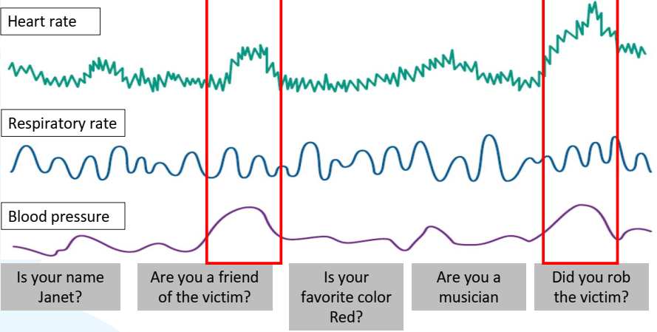

## 4.2 Cognitive model of panic (Clark, 1988)

**Application of James-Lange theory**

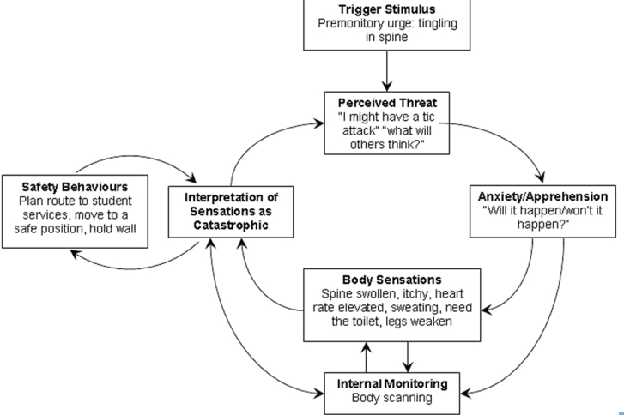Panic disorder is a psychological disorder in which people experience sudden peaks of fear and anxiety for no clear reason; they think they will die.

**Shows how a physiological reaction can precede emotional experience (sequence problem no. 1)**

## 4.3 Psychophysiological model of panic attacks (Ehlers et al., 1989)

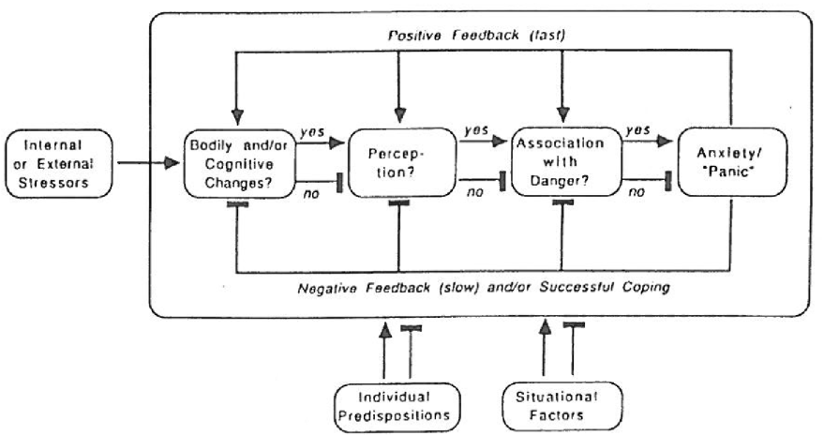

**Summary**

• Classical theoretical questions:  
1. Specificity problem  
2. Sequence I (James-Lange vs. Cannon-Bard vs. Schachter-Singer)  
3. Sequence II (Zajonc & LeDoux vs. Lazarus)  
• Contribution of the cognitive neurosciences to theoretical  
controversies:  
• Damasios theory and Becharas Iowa gambling task  
• LeDoux: quick-and-dirty processing of amygdala  
• Applications in cognitive models of panic disorder and lie detection